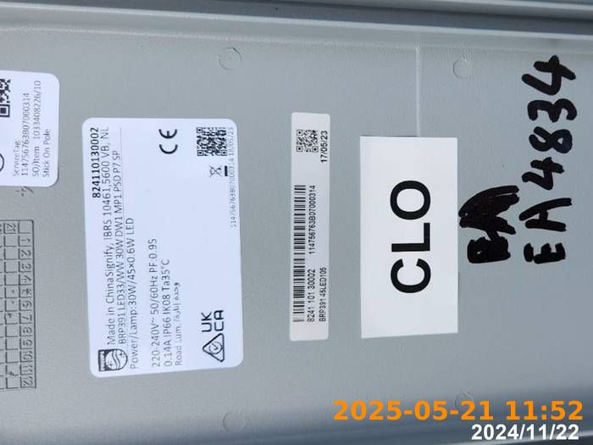 | 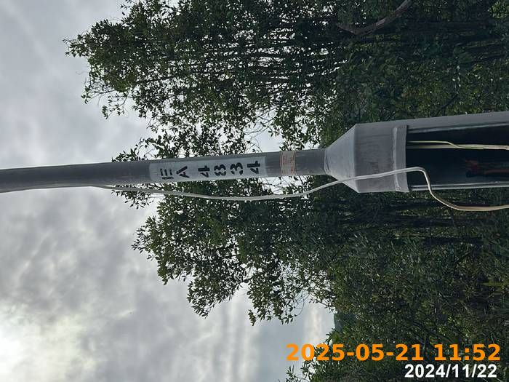 | 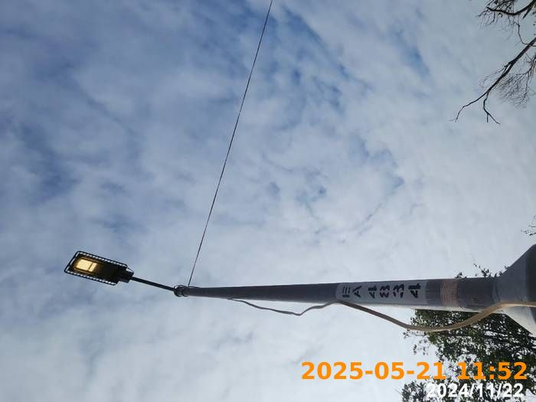
Damaged Column no.CE0865 | Damaged Column no.CE0865 | Replaced of New Column
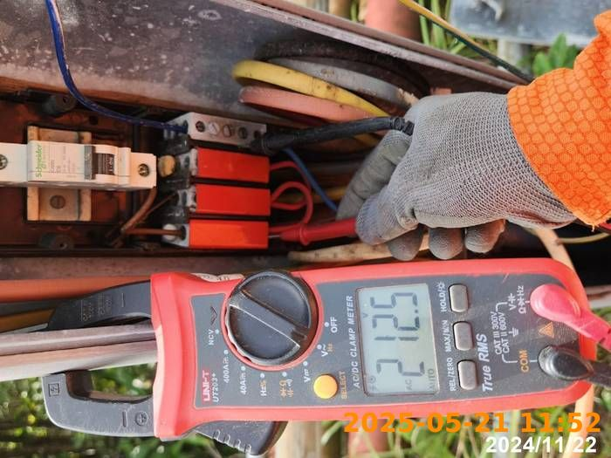 | 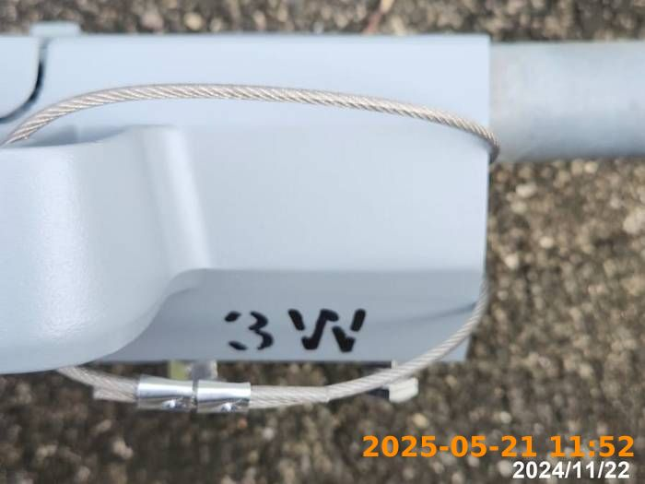 | 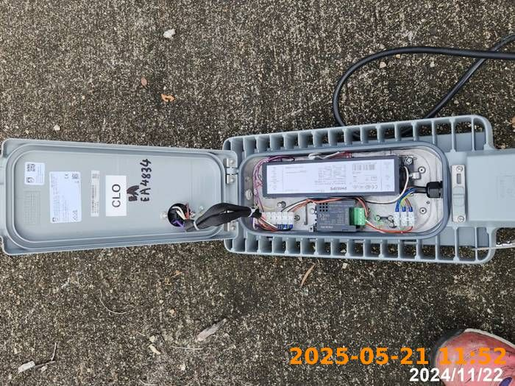
Column Depth | Column Depth | Concrete Surrounded
Concrete Surrounded | Interior of Column | Reinstatement
Lantern Lit on

Interior of Existing LED Lantern | Interior of Existing LED Lantern | Supply voltage
Supply current | Earth fault loop impedance  Existing circuit earth loop value, we cannot change the value by column replacement.  Chau Wai Sing:_____

.

